ANS – THD Division
Program Committee Virtual Meeting
June 5th, 2022
Attendees:
1. Opening
Opening by Dr. Bolotnov. This is the last meeting with Dr. Bolotnov as chair. Dr. Shaver will take over.
2. Approval of Meeting Agenda
The Draft Meeting agenda has been provided
MOTION to approve: Dave Pointer
SECOND by: Elia Merzari

NO DISCUSSION
APPROVED UNANIMOUSLY
3. Approval of Minutes from 2021 Winter Meeting
Draft minutes from 2021 Winter meeting were discussed. Minutes were posted late on the website. If errors are found, they can be communicated per email.

MOTION to approve: Xiaodong Sun
SECOND by: Bob Martin

NO DISCUSSION
APPROVED UNANIMOUSLY

4. Update on THD session for ANS 2022 Annual Meeting
Dr. Shaver provided an update on the ANS 2022 Annual Meeting. ATH is embedded in the conference.
92 submissions (with 11 rejections). The 81 accepted submissions include 53 full papers, 19 summaries and 9 contributions to the young professional competition. Trend on submissions is still positive. Other positive trend is the increased number of reviewers.
The list of technical sessions chairs was provided during the meeting. Session chairs were asked to check their availability and potential conflicts. Dr. Wu reported a conflict with one of the sessions. Jun Liao cannot attend the conference, and so he needs to be substituted. Dr. Bolotnov has a conflict with the NEAMS meeting. Dr. Sharma volunteers. Dr. Shaver will finalize by end of the week.
NO DISCUSSION
5. Update on THD Program for the upcoming 2022 Winter Meeting
Dr. Shaver presented the program for the upcoming meeting: 10 sessions are planned, 3 of those being panels. Submissions are due on June 30, 2022. Final summaries are due on Aug 8, 2022.
ANS is moving toward a no extension model, so no deadline extensions are expected.
NO DISCUSSION
6. Planning for the future 2023 Annual Meeting
The conference is planned for June 2023 in Indianapolis, IN.
Proposed sessions:
- Two-phase fundamentals – S. Sharma / X. Sun
- Experimental thermal-hydraulics – Y. Liu (V. Tech) / M. Delgado*
- Computational TH – Howard / Rao*
- General TH – W. Marcum / Y. Hassan*
- TH for advanced reactors – J. Liao / B.-W. Yang
- High resolution TH – I. Bolotnov / Fang*
- TH facilities, capabilities & current activities – Goth* / Carasik* / Y. Hassan*
Proposed panel: ARDP Follow-up – Shaver/Pointer
Suggested tour of Purdue – S. Kim*
*To be confirmed
Overall, a small TH program is expected for the 2023 Annual Meeting, given its proximity to the NURETH conference. Because of this, it has been decided not to have too much granularity in the sessions descriptions (i.e. no separate sessions for microreactors, SMRs, etc.)
The panel organizers needs to submit a description for the panel content.
7. NURETH 19 Update
DR. Roelofs was absent. Merzari shared the report presented in the newsletters. While there was still a hope to hold the conference in presence, in November it was decided to move to a full online conference. Accommodating the time zone of all participants turned out to be an enormous challenge.
The conference had a strong technical program with 614 presentations. The meeting was successful, though not ideal, the format allowed for some level of interactions among participants. Overall, positive feedback was received.
The meeting was financially successive. The conference organizers are looking into how to provide the donation to the TH Division. 100 papers were down selected for special issues in NED, NT, NSE. All authors have been notified.
A special session was hold in honor of Prof. Prasser’s retirement. In addition the TAA Lecture by Dr. Podowski, and the Sehgal Memorial award lecture by Dr. Merzari were held.
DISCUSSION
It was widely recognized that a lot of efforts went into organizing and leading the conference! Full appreciation goes to the organizing team.
8. NUTHOS-13 Update
Bao-Wen Yang gave an update on the conference. It is going to be held in hybrid form. Virtual papers presentations are going to be allowed. The location has been moved to Hsinchu, where Tsing Hua university is located (Taiwan). This is only 30 minutes from the internal airport, and therefore easier to reach.
Latest update on submissions: 38 from China, 27 from Japan, 40 from Korea, 10 from Taiwan, 14 from Germany, only 2 from US.
9. NURETH 20 Update
Dr. Bajorek gave an update on the NURETH-20 organization. Considering the experience with the past NURETH conference, there is still plan B of holding a hybrid format, but the current plan is for an in-person conference.
The conference is planned for Aug 20 – 25, 2023.
The call for papers has been submitted to ANS, which is revising the format. Bajorek asked whether a stack of the printed call for proposal can be taken to the next ANS Meeting for distribution. An email was sent to ANS to include the call for proposal in the ATH package. DR. Merzari mentioned that it is too late to put the printed call for papers in the ATH package. However, Dr. Merzari plans to bring a number of printed versions to the ATH meeting for distribution.
Dr. Bajorek had a meeting with the local ANS section to organize technical tours (cold neutron facility and research reactors, NIST facilities, etc.). Additional fees will be required for participation in a technical tour.
Dr. Bardet is looking at different venues for the conference. The plan is to finalize by summer/early fall.
NO DISCUSSION
10. ATH’24 Planning
Dr. Shaver gave an update about the conference. He is the technical program chair. Volunteers are needed for two general program chairs and technical co-chair. International representation is desired.
A conference form (similar as for the ATH’22) needs to be filled.
Dr. B.-W. Yang volunteered as general program chair together with Dr. Pointer.
Dr. Roelefs and Dr. Petrov are proposed as technical co-chairs.
Dr. Gutowski, Dr. Sharma and Dr. Liao volunteered as assistant technical chair. DR. Ibarra is proposed as additional assistant technical chair.
NO DISCUSSION
11. Old business
PC membership nomination
Dr. Marcum presented the group of nominations (see APPENDIX B).
Two additional members are presented: Dr. Shaver as chair, Dr. Gutowski as vice-chair.
DISCUSSION
Dr. Hassan asked whether Steven Arndt could be part of the program committee, being him also the ANS President. It was confirmed that this does not constitute a conflict and that Steven has continued to be quite active in the TH Division.
Dr. Bolotnov emphasized that there is a net reduction in memberships considering new members and the number of members who moved to the advisory council, and the need for everybody to volunteers with papers reviews.
According to the TH division bylaws, additional members could be added. There is also a rule in our bylaw that states that members who do not attend two consecutive PC meetings or do not participate as reviewers in two consecutive TH-sponsored meetings are no longer considered active members of the PC committee.
12. New business
Dr. Shaver brought up an issue with the Young Professional Competition session. Currently, there is ahigh number of summaries submitted to the Young Professional Competition. Submission needs also to be streamlined, as participants are not following the instructions: there are participants who submit a full paper to the competition instead of summary, and participants who have double submissions to both the regular session and the competition.
Dr. Shaver proposed to provide the option to participate (with one click) to the competition with their regular session full paper. Then, the top 5 contributions will be selected for a special session.
Dr. Wade did not agree on capping the top 5 contributions. Therefore, Dr. Yang proposed to arrange a zoom meeting in which to invite the candidates to give a 5-minute pitch of their work. The pitch can be then used to down select the candidates who would compete with a full presentation within the Young Professional Competition session.
Yassin Hassan asked to consider increasing the number of awards, given the considerable increase of participants. An award certificate (instead of $$) would work too.
Dr. Bolotnov concluded the meeting with a few words about his time as chair and presented his best wishes to the incoming chair and vice-chair.
Meeting was adjourned.

APPENDIX A
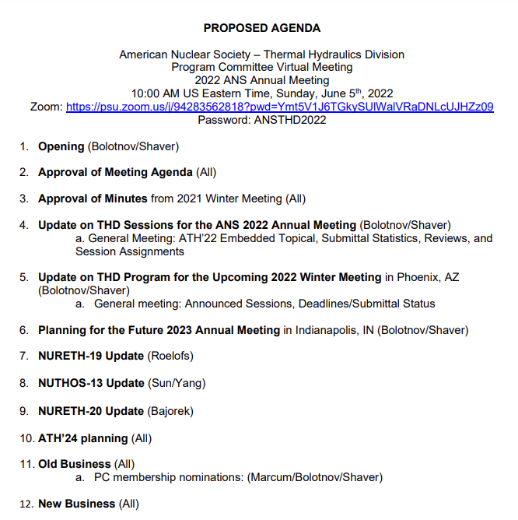
APPENDIX B
